https://www.getpaint.net/doc/latest/index.html:
Revision Date: 6 May 2017
Overview/Features
paint.net 4 is the best free image and photo editing application for Windows based PCs since paint.net 3.5. The application has been extensively rebuilt to improve functionality and ease of use while packing numerous new features into the now familiar user interface (UI).
paint.net 4 works exclusively on the Windows operating system, requiring Windows 7 SP1 and the .NET Framework 4.6 as a minimum.
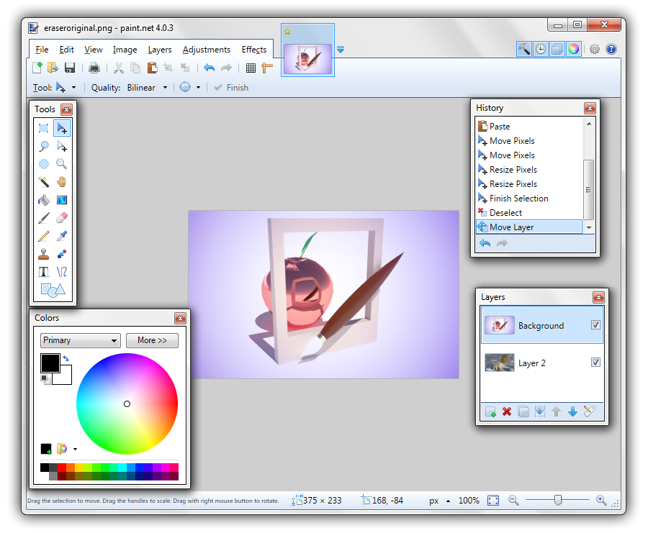User Interface (UI)
Some key features of paint.net 4:

The same intuitive user interface
Every feature and user interface element in paint.net has been redesigned to be intuitive and easily learned without assistance. paint.net 4 has improved the discoverability of new features while building on the now familiar User Interface (UI) of 3.5x. Users of previous versions of paint.net will recognize the familiar interface, as should users of MS Paint and Adobe Photoshop.

Open & edit multiple images
paint.net is able to simultaneously open multiple images and uses a tabbed document interface much like a modern web browser. Instead of a piece of descriptive text, the tabs display a live thumbnail of the open image.
Image tabs make navigation very simple and fast, using only a single click to navigate to a new image. New to paint.net is that the image tabs can be reordered with drag-and-drop.
Each open image shows up as its own Windows taskbar item (this can be disabled in the brand new Settings dialog).

Layers
Layers allow an image to be composed from a stack of images that are blended together.
paint.net supports many layer blend modes, layer transparency and reordering of layers with drag-and-drop.

Unlimited History
Every editing action performed on an image is recorded in the History window. The History list makes undoing actions as simple as clicking on a previous entry in the list.
The number of actions stored in an editing session is limited only by available disk space and memory.

Support for many popular file formats
paint.net supports numerous common file formats: PNG, JPEG, BMP, GIF, TGA, DDS, and TIFF.
The native paint.net image type (*.PDN) preserves the layer structure of a composite image and is lossless, meaning no data is lost when saving in this native format.
Many third-party tools (plugins) exist which extend the number and types of files paint.net can utilize.

Performance optimized for today's hardware
paint.net is optimized for the latest in multi-core processor technology, sporting a brand new, asynchronous, fully multithreaded rendering engine.
This new engine allows performance to scale with respect to the number of CPU cores whether you have 2, 4, 6, or even 16 of them.
paint.net will run on both 32-bit and 64-bit version of Windows.

Automatic updates
Updates are free, and contain new features, performance improvements, and bug fixes. Upgrading to the latest version is very simple, requiring only a few clicks of the mouse.

Extensive language support
paint.net ships with 22 languages. Eleven more than 3.5x.
Available languages are: Chinese (Simplified), Chinese (Traditional), Czech, Danish, Dutch, English, Finnish, French, German, Hindi, Hungarian, Italian, Japanese, Korean, Lithuanian, Persian, Polish, Portuguese (Brazilian), Portuguese (Portugal), Russian, Spanish & Swedish.
Many third-party language packs are available. If your language is not presently supported check the paint.net forum for a free downloadable language pack.

Extensibility
paint.net supports third-party developed plugins which add new effects, adjustments, and file format support.

Active community
The paint.net forum is a friendly, passionate, and ever-expanding online community of paint.net users. The forum is family friendly. There you will find user discussions, help, tutorials, galleries and resources (like plugins and palettes) to download.
Access the forum from within paint.net by clicking the Help icon in the Tool Bar and selecting Forum from the menu.

